Types of Machine Learning

Machine Learning is classified into three types. Based on type of the data dealing with its divided into following types

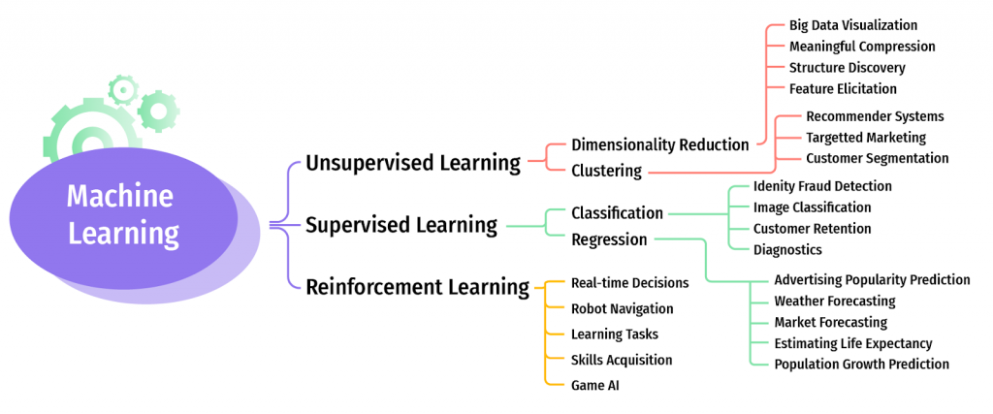

Supervised Machine learning algorithmns:

* [Decision Trees](https://www.newtechdojo.com/list-machine-learning-algorithms/#Decision%20Trees)
* [Naive Bayes Classification](https://www.newtechdojo.com/list-machine-learning-algorithms/#Naive%20Bayes%20Classification)
* [Support vector machines for classification problems](https://www.newtechdojo.com/list-machine-learning-algorithms/#Support%20vector%20machines%20for%20classification%20problems)
* [Random forest for classification and regression problems](https://www.newtechdojo.com/list-machine-learning-algorithms/#Random%20forest%20for%20classification%20and%20regression%20problems)
* [Linear regression for regression problems](https://www.newtechdojo.com/list-machine-learning-algorithms/#Linear%20regression%20for%20regression%20problems)
* [Ordinary Least Squares Regression](https://www.newtechdojo.com/list-machine-learning-algorithms/#Ordinary%20Least%20Squares%20Regression)
* [Logistic Regression](https://www.newtechdojo.com/list-machine-learning-algorithms/#Logistic%20Regression)
* [Ensemble Methods](https://www.newtechdojo.com/list-machine-learning-algorithms/#Ensemble%20Methods)

Un-Supervised Machine learning algos:

* [K-means for clustering problems](https://www.newtechdojo.com/list-machine-learning-algorithms/#K-means%20for%20clustering%20problems)
* [Apriori algorithm for association rule learning problems](https://www.newtechdojo.com/list-machine-learning-algorithms/#Apriori%20algorithm%20for%20association%20rule%20learning%20problems)
* [Principal Component Analysis](https://www.newtechdojo.com/list-machine-learning-algorithms/#Principal%20Component%20Analysis)
* [Singular Value Decomposition](https://www.newtechdojo.com/list-machine-learning-algorithms/#Singular%20Value%20Decomposition)
* [Independent Component Analysis](https://www.newtechdojo.com/list-machine-learning-algorithms/#Independent%20Component%20Analysis)

Reinforecement algos:

